Feature Importance

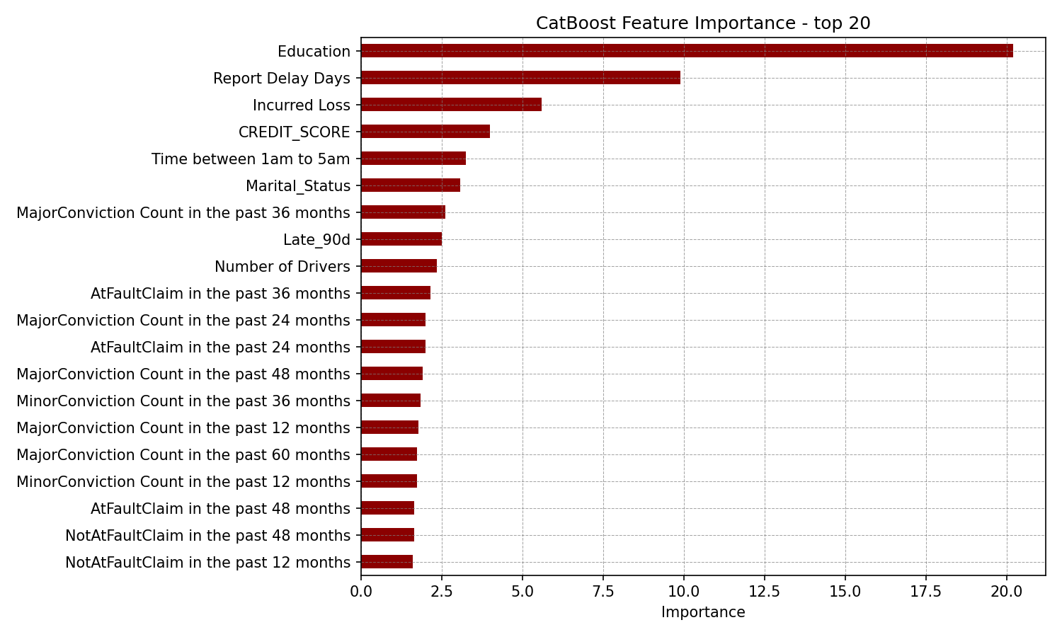
Rank | Feature | Importance
1 | Education | 20.21
2 | Report Delay Days | 9.88
3 | Incurred Loss | 5.61
4 | CREDIT_SCORE | 3.99
5 | Time between 1am to 5am | 3.25
6 | Marital_Status | 3.07
7 | MajorConviction Count in the past 36 months | 2.62
8 | Late_90d | 2.51
9 | Number of Drivers | 2.35
10 | AtFaultClaim in the past 36 months | 2.15
11 | MajorConviction Count in the past 24 months | 2.00
12 | AtFaultClaim in the past 24 months | 1.99
13 | MajorConviction Count in the past 48 months | 1.91
14 | MinorConviction Count in the past 36 months | 1.84
15 | MajorConviction Count in the past 12 months | 1.77
16 | MajorConviction Count in the past 60 months | 1.74
17 | MinorConviction Count in the past 12 months | 1.73
18 | AtFaultClaim in the past 48 months | 1.66
19 | NotAtFaultClaim in the past 48 months | 1.65
20 | NotAtFaultClaim in the past 12 months | 1.60
21 | NotAtFaultClaim in the past 24 months | 1.59
22 | Age | 1.57
23 | Financial Claim Indicator | 1.55
24 | MinorConviction Count in the past 48 months | 1.50
25 | Seat_Belt | 1.36
26 | MinorConviction Count in the past 24 months | 1.36
27 | NotAtFaultClaim in the past 60 months | 1.15
28 | INCOME | 1.12
29 | AtFaultClaim in the past 60 months | 1.10
30 | Loyalty_year | 1.00
31 | NotAtFaultClaim in the past 36 months | 0.95
32 | MinorConviction Count in the past 60 months | 0.82
33 | Yrs_Licensed | 0.81
34 | Horse Power | 0.80
35 | Loss Month | 0.78
36 | Make | 0.76
37 | AtFaultClaim in the past 12 months | 0.74
38 | Coverage Amount | 0.73
39 | Number of Vehicles | 0.71
40 | Model | 0.64
41 | Non-Pay Cancellation Count | 0.61
42 | Luxury Vehicle Indicator | 0.61
43 | Loss Year | 0.56
44 | Time_Rural | 0.56
45 | Time_Urban | 0.51
46 | Exposure | 0.42
47 | Policy Age Days | 0.37
48 | Prior insurance | 0.35
49 | Note minor | 0.34
50 | Gender | 0.28
51 | Number of Billing Accounts | 0.22
52 | Model Year | 0.20
53 | Loss Weekday | 0.20
54 | Note rear-ended | 0.11
55 | Note intersection | 0.03
56 | Note major | 0.00
57 | Note moderate | 0.00
58 | Note injury | 0.00
59 | Note sideswiped | 0.00
60 | Source | 0.00
61 | Catastrophe Event Indicator | 0.00
62 | Vehicle Type | 0.00
63 | Towing indicator | 0.00
64 | Claim Branch Number | 0.00
65 | Product_cd | 0.00
66 | Anti-Theft Device Indicator | 0.00
67 | Suspensions Count | 0.00
Evaluation charts
Both charts use the untouched 2025 test claims and show the CatBoost model (blue) next to the logistic regression benchmark (orange).

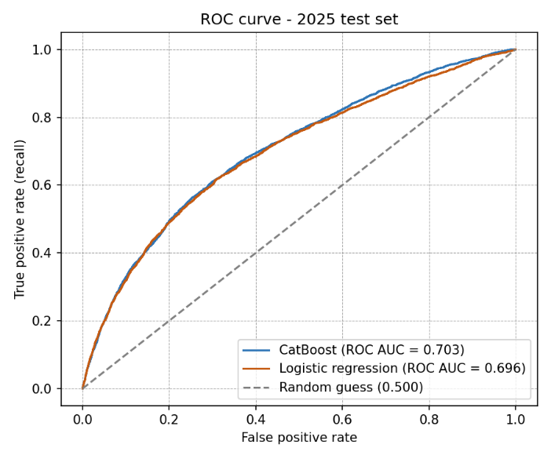
ROC curve chart:
This chart shows how many fraud claims the model catches (true positive rate - up) compared with how many non-fraud claims it wrongly flags (false positive rate, along the bottom) as the cutoff is moved. The dashed diagonal line is random guessing. The further the curve bends toward the top-left corner, the better. CatBoost has a ROC AUC of 0.703 and logistic regression 0.696. In plain terms, if we pick one fraud claim and one non-fraud claim at random, CatBoost gives the fraud claim the higher score of about 70% of the time. That is a real but moderate signal: the model ranks claims well enough to help, but it cannot cleanly separate fraud from non-fraud claims.
Precision-recall curve chart:
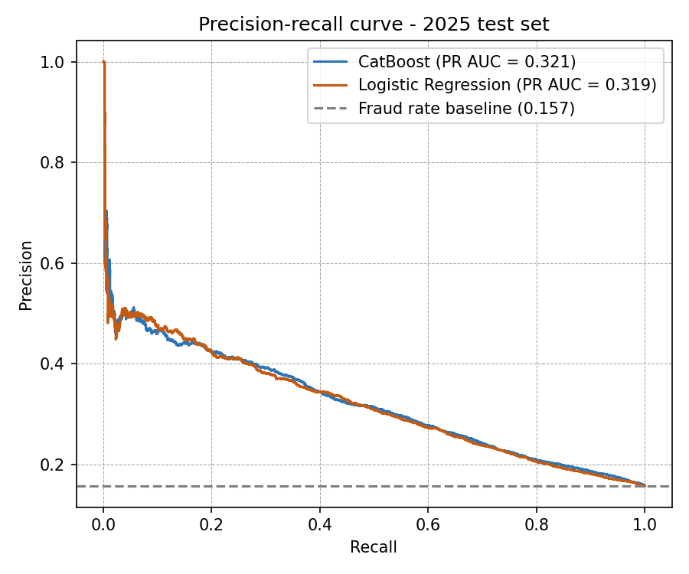
This chart focuses only on fraud cases, which matters because fraud is only about 16% of claims. Recall (along the bottom) is the share of all fraud the model finds, and precision (up) is the share of flagged claims that are really fraud. The dashed line is the fraud rate, which is the precision we would get by flagging claims at random. Both curves sit well above that line on the left side: when only the highest-risk claims are flagged, about 40% to 45% of them are fraud, close to three times the base rate. As we push to find more fraud, precision drops toward the baseline. This is the trade-off the business must choose: a small, high-quality review list, or a larger list that catches more fraud but includes more non-fraud claims. At the chosen cutoff, the model finds 53% of fraud with 30% precision. CatBoost's PR AUC is 0.321 versus 0.319 for logistic regression, about twice the baseline.
Model comparison:
The two curves nearly overlap. CatBoost is slightly ahead on both measures (ROC AUC 0.703 vs 0.696; PR AUC 0.321 vs 0.319), so it was kept as the final model, but the gap is small. This tells us most of the useful signals are simple, and a logistic regression could serve as an easy-to-explain backup model.

